**Phase – II**

**Practice Project – I**

**Validation of the User Login**

**Sai Krishna Rajagopal**

**16-03-2022**

**GITHUB Repository URL:** [**https://github.com/SaiKrishna6699/JavaFSDTraining.git**](https://github.com/SaiKrishna6699/JavaFSDTraining.git)

**Technical Summary:**

1. **HTML, CSS**
2. **Java EE**
3. **Eclipse**
4. **Web Browser (Chrome)**
5. **Tomcat 8.5**
6. **Git**
7. **HTML, CSS:**

A html page named Index.html with minimal CSS is created, which consists of a HTML Form takes input for the login.

1. **Java EE:**

The validation of USER Login was developed in Java Enterprise Edition (Java EE) using the concept of Servlets.

The Application is fully Functional and Working Perfectly with No Exceptions.

Short Summary of Code:

* In this Application there are three Java Servlets for full functional working of the application.
* Login, Dashboard and Logout are the Java Servlet Programs created for Login Validation.
* Login:
  + In the Login Servlet, It works on the response from the Index HTML page. The doGet method is used to request and take response from the HTML Page using Http Servlet package.
  + String Username and Password is created to store the parameters from the HTML page for Username and Password.
  + A HTTP session object gets created to track the session of the user.
  + Later the User Input will be verified to check whether the login credentials are valid.
  + If it is valid then the session gets redirected to Dashboard servlet.
  + Else if not valid it will generate an error message in the Index html page.
* Dashboard:
  + In the Dashboard Servlet, The User details were collected from the session tracking using the session ID.
  + In the Dashboard It generates a message “Welcome, User”. Here The User name will be fetched using the Http Session Tracking.
  + Dashboard also contains the href to logout, which will redirects the page to Logout Servlet.
* Logout:
  + In the Logout Servlet. The Session will be terminated.
  + The Session Termination is archived using getSession().invalidate().

1. **Eclipse:**

Eclipse is the IDE used to Write the code. It is a very programmer friendly and easy to use application.

1. **Tomcat 8.5:**

Apache Tomcat is a webserver which is used to host web apps locally in the system. In this project Tomcat 8.5 is used to host the Servlet application. Tomcat 8.5 supports Java 7 and other latest versions of the Java EE.

1. **Git & GitHub:**
   1. Git is the version control system used to store the data in a remote Repository.
   2. GitHub is the remote data base contains repository which is used to store the data.

Git Commands used:

$git init

$git remote -v

$git add .

$git commit -m “Adding PP1”

$git branch -M master

$git push -u origin master

1. Screenshots:

Output:

Login:

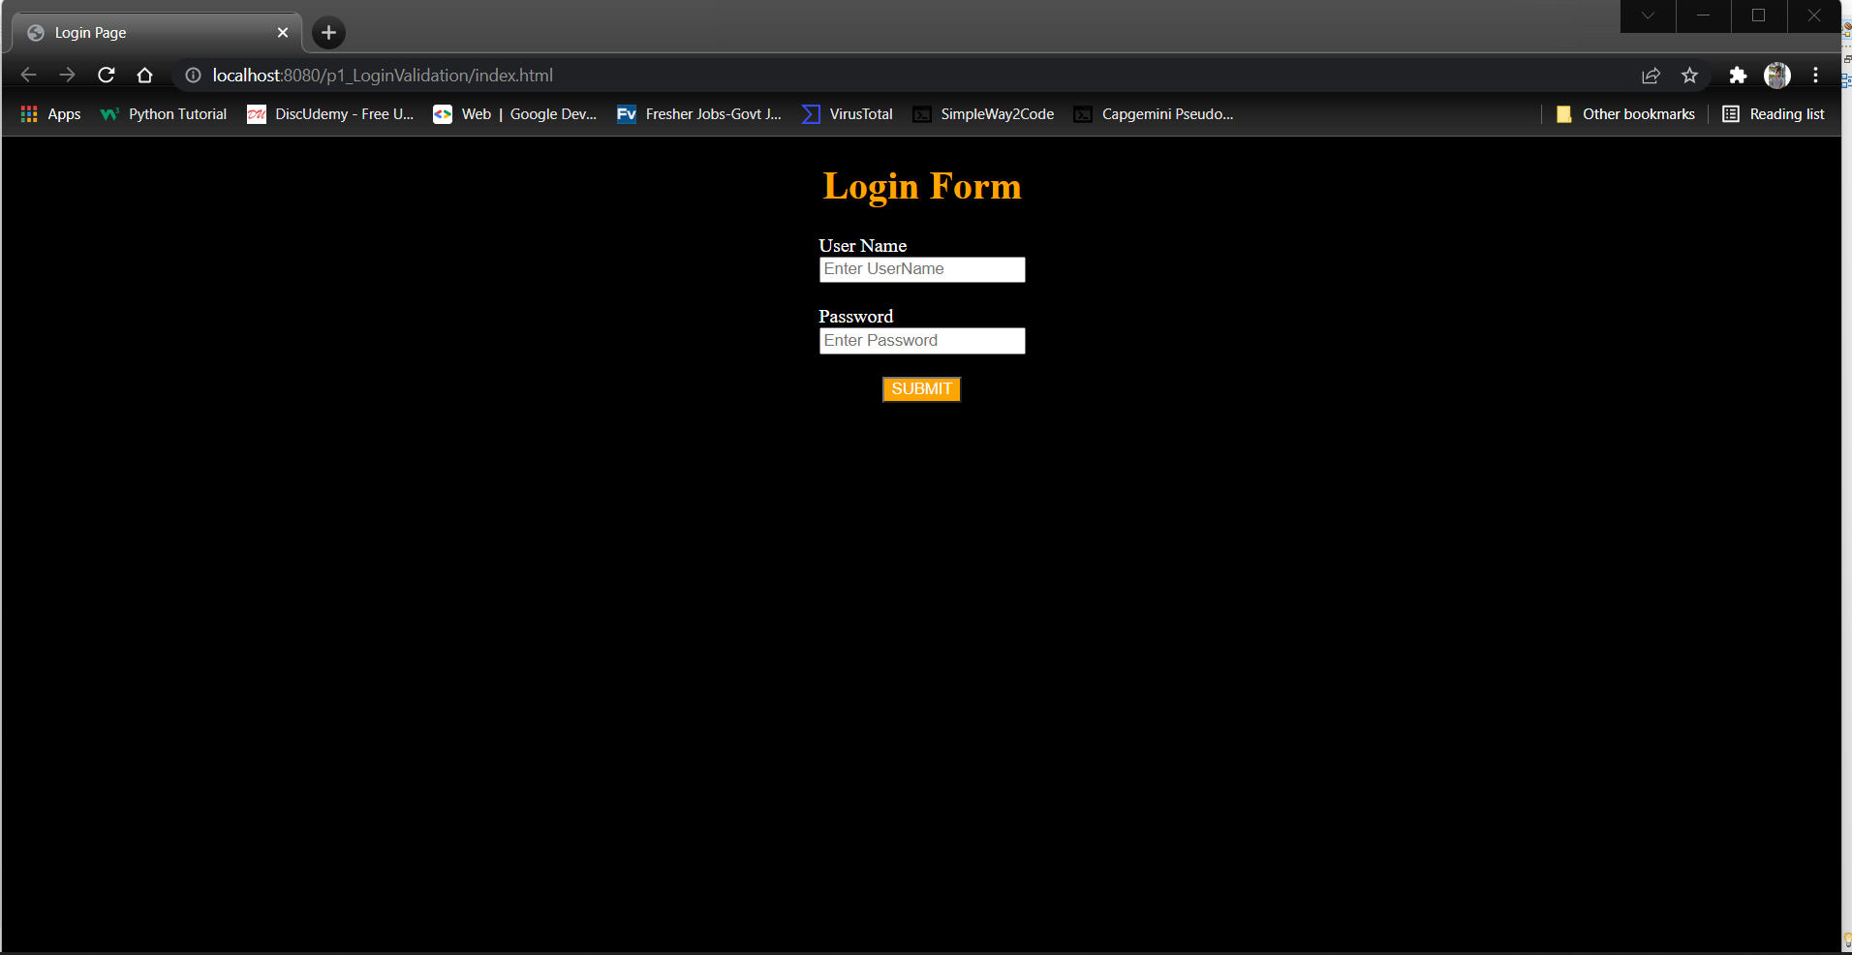

Invalid Login:

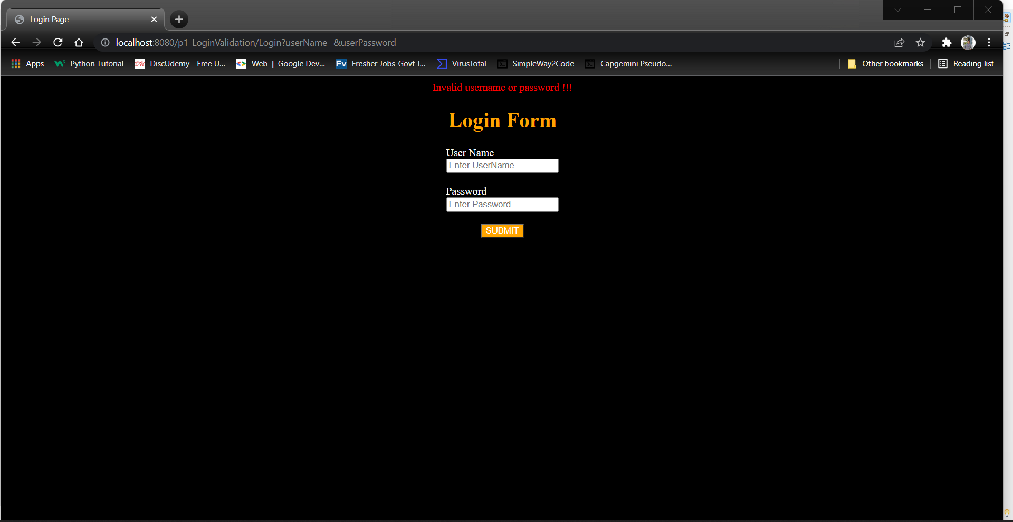

Dash board: After Login:

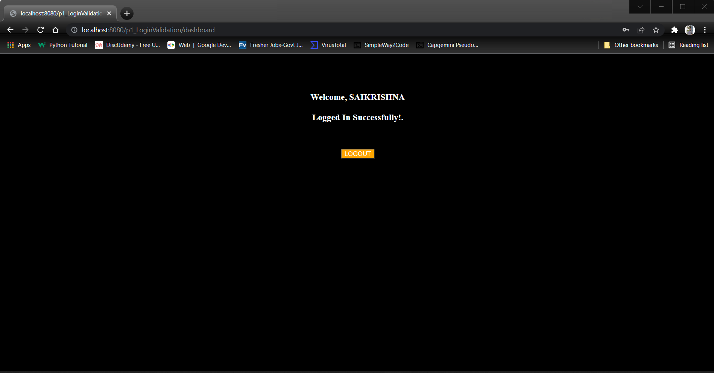

Logout:

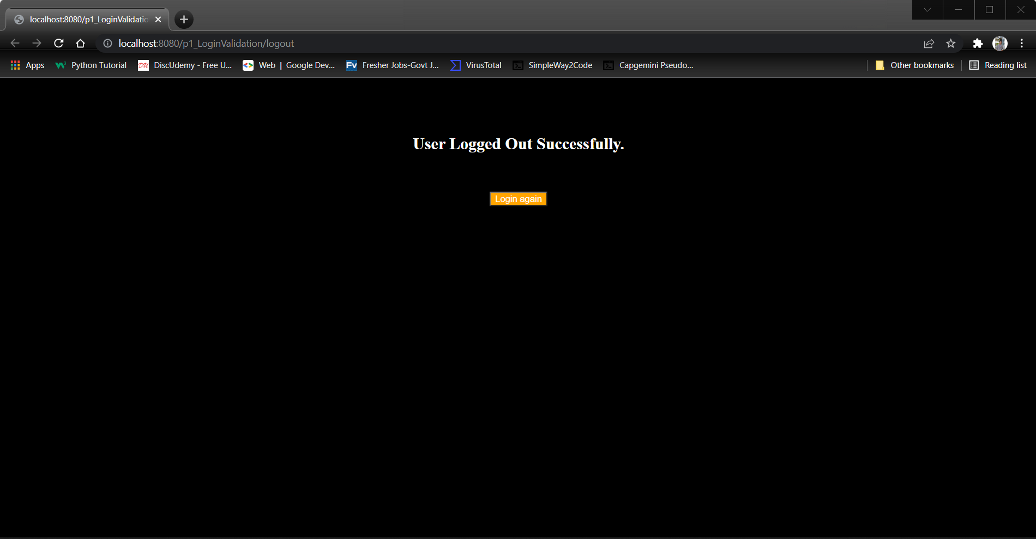

Git:

